- Taxable Acquisitions of Freestanding C Corporations
  - Tax Consequences of Alternate Forms of Corporate Acquisitions: For a summary of the tax consequences of the different acquisition structures, see Table 12.1 (p. 12-3).
    - Case 1: Asset Acquisition without Liquidation of Target: Gain and loss (usually gain) is recognized by the target corporation including ordinary income on the sale of depreciated equipment and machinery. If the target corporation has any NOLs, they can be used by the target to offset net gain from this sale. The acquiring corporation allocates its cost basis among the acquired assets using the residual valuation approach under section 1060. Under section 1060, basis is first allocated to cash and bank deposits (class 1), then to marketable securities, foreign securities, and similar items (class 2), then to assets subject to mark-to-market rules as well as receivables (class 3), then to section 1231 assets and inventory (class 4), then to section 197 intangibles other than goodwill and going-concern value (class 6), then to goodwill and going-concern value (class 7). Finally, anything not in classes 1, 2, 3 ,4, 6 and 7 are allocated to class 5. You are not responsible for knowing the definitions of these classes.
    - Case 2: Asset Acquisition Followed by Liquidation: As in case 1, the target corporation recognizes gain and loss on the sale of its assets and any target NOLs are available to offset such gain. In addition, the target shareholders will recognize gain or loss on the liquidation of the target corporation. The acquiring corporation will have a cost basis in its assets, allocated under section 1060.
    - Case 3: Stock Acquisition Followed by a §338 Election: Because of the election under §338, this transaction is taxed as if the acquiring corporation purchased the assets of the target corporation, followed by a liquidation of the target corporation. Thus, the taxation is identical to Case 2. To compute the deemed price for the assets of the target corporation, we must compute the “aggregate deemed sale price,” or ADSP. The ADSP equals the price actually paid by the acquiring corporation for the target’s stock plus any liabilities of the target corporation plus any tax that would be imposed on the target if the acquiring had actually purchased the target’s assets. Note that if this amount had been paid for the target’s assets, then after the target’s liabilities had been paid and taxes on the asset sale had been remitted to the federal government, the amount left for distribution on a liquidation of the target would equal the amount the shareholders actually receive in the actual stock sale. As in case 2, if the target has any NOLs available, they can offset the deemed gain on the deemed asset sale (up to 80% of the target’s taxable income because of the new limitation in §172). Again, the deemed sale price is allocated among the assets under the rules of section 1060.
      - Note that because the target corporation is owned by the acquiring corporation after the transaction, any target tax liability resulting from the deemed asset sale will implicitly be a burden on the acquiring corporation because it reduces the value of its now wholly-owned subsidiary corporation.
      - Because the tax imposed on the target shareholders is not affected by the §338 election, the target shareholders are not a party to the election: it is made by the acquiring corporation alone.
    - Case 4: Stock Acquisition without a §338 Election: The target shareholders are taxed on their gain or loss, and there is no cost basis in the target’s assets. Target assets generally continue but forward use of NOLs is limited by section 482 because of the ownership change.
  - Comparison of Taxable Acquisition Structures: Case 4 generally is the most tax-advantageous choice because the cost of obtaining a corporate step-up in asset basis exceeds the tax benefit of the step-up. However, this assumes that the target corporation is fully taxable on the gain from the asset sale. If the sale is subject to reduced taxation (possibly because the target corporation has NOLs that can offset the asset gain), then the other structures can become optimal. Note how the analysis is done: the purchase price is determined so that it makes one party indifferent, and then the transaction is analyzed from the perspective of the other party.
  - Discussion Questions (p. 15):
    - Question 1: Assuming the term “sale” excludes a tax-free reorganization, the main issues are: (1) how large will the selling shareholder’s gain be, and (2) what is the nature of the gain (short term capital gain or long term capital gain); and (3) should the purchaser file an election under §338 (not §338(h)(10)).
    - Question 2: The disadvantage of changing the tax basis of the target’s assets is the tax due immediately on the sale or deemed asset sale (under section 338). Any tax benefits will be realized over a period of years (e.g., 15 years for intangibles), while the tax on those benefits is payable in the current period.
    - Question 3: Generally yes.
    - Question 4: In acquisitions of freestanding C corporations, taxable asset acquisitions or taxable stock acquisitions followed by a regular 338 election. This rarely happens because the cost of the asset basis step-up is immediate while the benefits generally will be enjoyed only over time.
    - Question 5: Benefits include: (1) it may be possible to acquire the target’s business without acquiring undisclosed liabilities unsecured by the target’s assets; and (2) unwanted assets can be left behind.
    - Question 6: Benefits include: (1) some assets may be difficult to move (such as ground leases) and a stock acquisition avoids this problem; (2) some target loans may not have provisions triggering immediate repayment if ownership of the target changes, and such loans can be left in place; and (3) some assets may be expensive to transfer (such as real estate), and such costs can be avoided.
  - Tax-Planning Problems (p. 16):
    - Problem 12-7:
      - Part (a): Gain on the asset sale equals $10,000 less $250, or $9,750, generating a corporate tax liability of $3,900. If the after-tax proceeds of $6,100 are then distributed to the shareholders, there will be a capital gain of $6,095, yielding a tax of $1,219, leaving $4,881 after taxes. The same result can be obtained directly from equation 12.3 (p. 12-11) with a t_{c} of 40% and a t_{cg} of 20%.
      - Part (b): From equation 12.8 (p. 12-13), net after-tax cost equals AcqPrice – [(AcqPrice – Asset Basis)/n] times (the present value of an annuity for n year) times the corporate tax rate. Here, the AcqPrice = $10,000, the Asset Basis = $250, the value of a 15-year annuity (assuming a discount rate of 15%) equals 5.847, and the corporate tax rate equals 40%. Therefore, the after-tax cost equals 10,000 – 5.847*0.40*(10,000-250)/15, or $8,479.68.
      - Part (c): Using equation 12.6 at page 12-11, PRICE_{asset} = (Price_{stock} – ASSET*t_{c})/(1 – t_{c}), or $10,000 = (PRICE_{stock} – [$250*0.40])/(1 – 0.40), or $10,000(1 – 0.40) = PRICE_{stock} - $250*0.40, or $6,000 = PRICE_{stock} - $100, or PRICE_{stock} = $6,100. The after-tax cost to Wolverine is $6,100 because there is no tax benefit to a stock acquisition without a §338 election.
      - Part (d): ADSP = P + L +t(ADSP – BASIS) (see the top of page 12-7), or ADSP = $6,100 + $0 + 0.40(ADSP - $250), or ADSP = $10,000. The after-tax cost equals $8,479.68, just as in part (b), for the same reason as in part (b).
      - Part (e): Since the shareholders of the target are indifferent between the plans in parts (a) – (d), the transaction with the lowest after-tax cost to the acquiring corporation is optimal. That is the stock acquisition without a §338 election.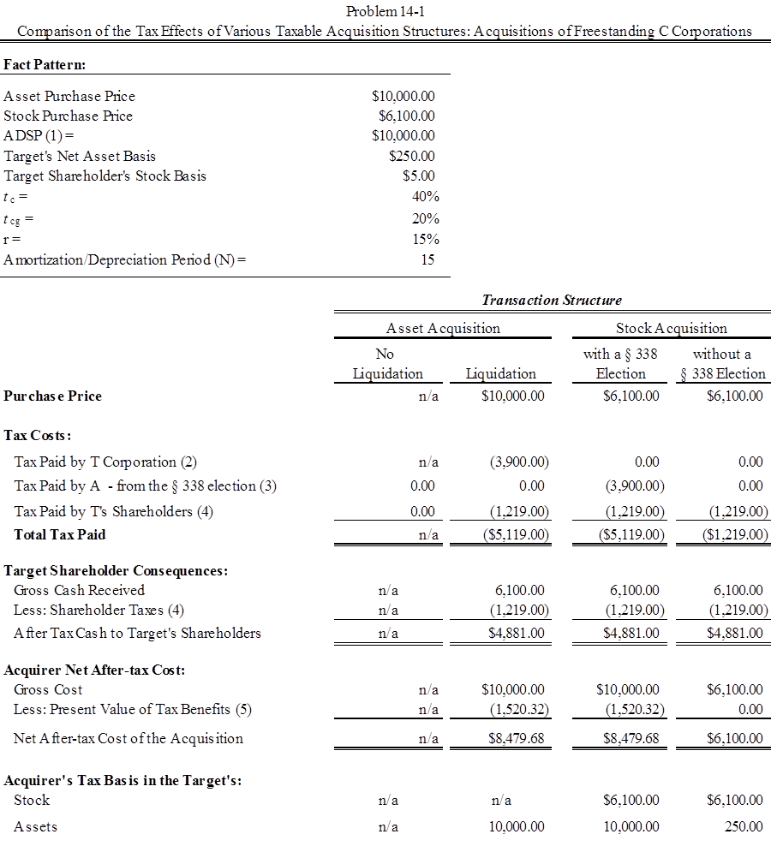
    - Problem 12-8:
      - Part (a): Using equation 12.3 (p. 12-11), ATAX_{asset} = [Price_{asset}(1 – t_{c}) + Asset*t_{c}](1 – t_{cg}) + Stock*t_{cg} = [$18.0(1 – 0.21) + $14*0.21]($1 – 0.80) + $1*0.20 = [$14.22 + $2.94](1 - 0.20) + $0.20 = $13.93 (all values in millions).
      - Part (b): Using equation 12.6 (p. 12-11), Price_{asset} = (Price_{stock} – Asset *t_{c})/(1 – t_{c}), or $18 = (Price_{stock} – $14.0*0.21)/(1 – 0.21), or $18 = (Price_{stock} – $2.94)/(0.79), or $18*0.79 = Price_{stock} – $2.94, or Price_{stock} = $17.16.
      - Part (c): $21.25 - $18.0 = $3.25.
      - Part (d): $20.0 - $17.16 = $2.84.
    - Problem 12-9:
      - Part (a): Gain on the asset sale is $7.0 million less $3.5 million, or $3.5 million, of which $2.5 million is sheltered by the NOLs, leaving $1.0 million of taxable gain, so the tax liability equals $210,000. If the after-tax proceeds of $6.79 million are then distributed to the shareholders, they will recognize a taxable gain of $0.79, taxed at 20%, for a tax liability of $0.160 million. Therefore, the net proceeds to the shareholders will equal $6.63 million.
      - Part (b): To make the shareholders indifferent, they must receive $6.63 million after their taxes. From part (a), we know that a payment of $6.79 million to the shareholders will generate a tax liability of $0.13 million, leaving $6.63 million after taxes. Thus, the shareholders must be paid $6.79 million.
      - Part (c): Since Walker will receive a business it values at $8.75 million at a cost of $7 million, the net present value to Walker of option 1 equals $1.75 million.
      - Part (d): Since Walker will receive a business worth $8 million at a cost of $6.79 million, the net present value of option 2 equals $1.21 million.
      - Part (e): The asset sale (option 1) is optimal.

